INSTRUCCIONES:

REPRODUCIR LOS EJEMPLOS DE LOS QUERIES ILUSTRADOS EN EL MANUAL “SQLBAS05 OK” (TODAS LAS LÁMINAS) UTILIZANDO LAS TABLAS

* IBMUSER.EMP
* IBMUSER.DEPT

Y CAPTURANDO PARA CADA CASO 2 PANTALLAS:

* PANTALLA CON LA CODIFICACIÓN DEL QUERY.
* PANTALLA CON LA SALIDA DE LA EJECUCIÓN DEL QUERY (INCLUYENDO POSIBLES PANTALLAS DE ERROR).

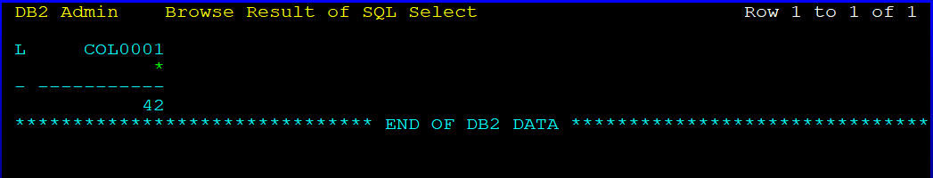

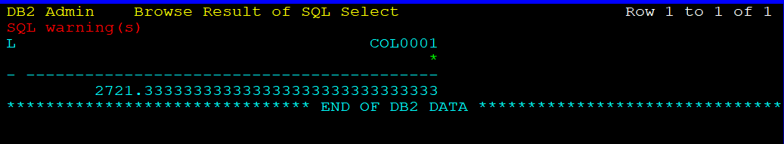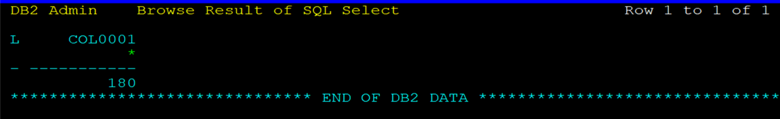

SELECT AVG(PHONENO) FROM IBMUSER.EMP WHERE JOB='ANALYST';

SELECT COUNT(\*) FROM IBMUSER.EMP, IBMUSER.DEPT D WHERE IBMUSER.EMP.WORKDEPT ADMRDEPT=V. ADMRDEPT AND WORKDEPT = ‘A00’;

SELECT COUNT(\*) FROM IBMUSER.EMP WHERE JOB='ANALYST';

SELECT COUNT(DISTINCT JOB) FROM IBMUSER.EMP;

SELECT COUNT(\*) FROM IBMUSER.EMP;

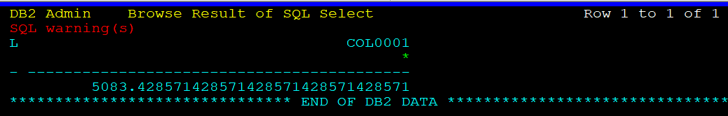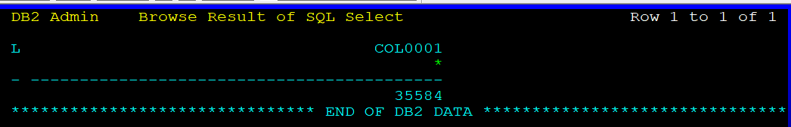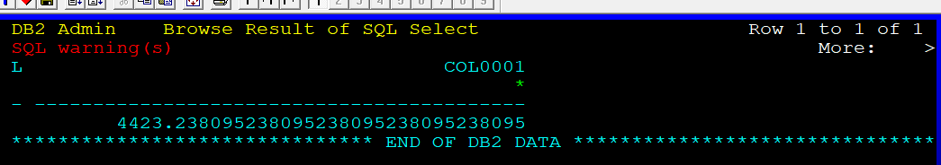

SELECT AVG(PHONENO) FROM IBMUSER.EMP WHERE JOB = 'MANAGER';

SELECT SUM(PHONENO) FROM IBMUSER.EMP WHERE JOB='MANAGER';

SELECT AVG(PHONENO), AVG(DISTINCT PHONENO) FROM IBMUSER.EMP;

SELECT AVG(PHONENO) FROM IBMUSER.EMP WHERE WORKDEPT = 'D11';

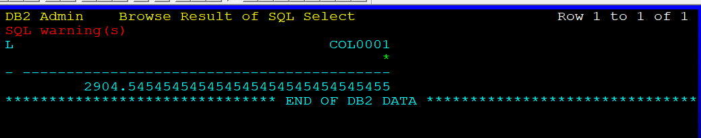

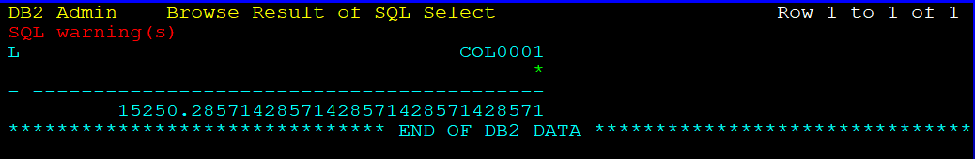

SELECT AVG(PHONENO\*3) FROM IBMUSER.EMP WHERE JOB = 'MANAGER';

SELECT MAX(PHONENO), MIN(PHONENO) FROM IBMUSER.EMP;

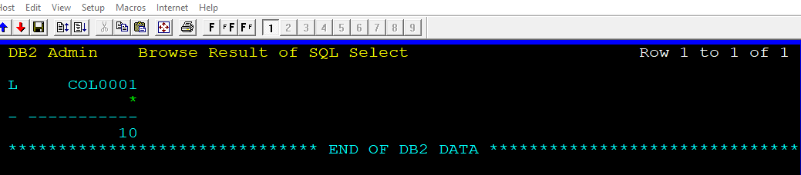

SELECT COUNT(PHONENO) FROM IBMUSER.EMP WHERE JOB='DESIGNER';

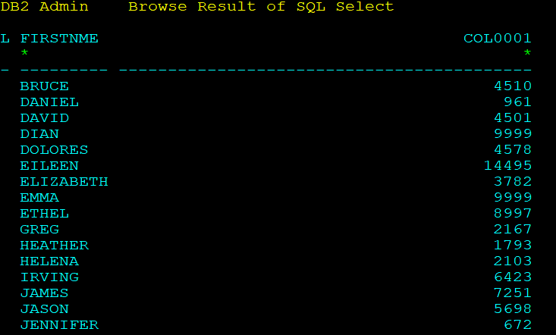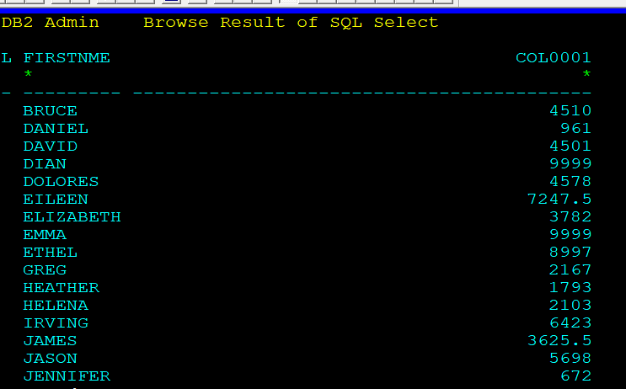 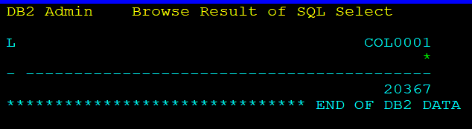

SELECT FIRSTNME, SUM(PHONENO) FROM IBMUSER.EMP GROUP BY FIRSTNME;

SELECT FIRSTNME, AVG(PHONENO)

FROM IBMUSER.EMP GROUP BY FIRSTNME;

SELECT AVG(DISTINCT PHONENO\*3) FROM IBMUSER.EMP

WHERE WORKDEPT='E01';

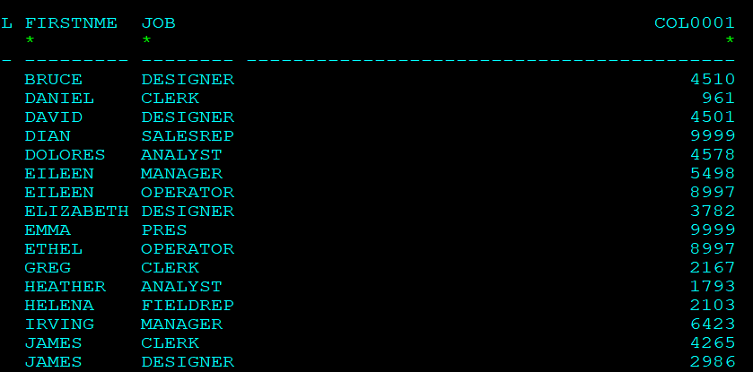

SELECT FIRSTNME, JOB, SUM(PHONENO) FROM IBMUSER.EMP

GROUP BY FIRSTNME, JOB;

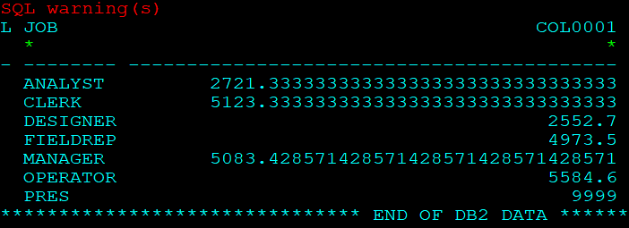

SELECT JOB, AVG(PHONENO) FROM IBMUSER.EMP

WHERE WORKDEPT <>'A00' GROUP BY JOB;

SELECT HIREDATE, AVG(PHONENO) FROM IBMUSER.EMP

GROUP BY HIREDATE ORDER BY 2 DESC;